

**SOFTWARE REQUIREMENTS SPECIFICATION DOCUMENTS**

**(Software Requirement Specification – SRS)**

**Developing sneaker online shop system**

**Version 1.0.1**

**Guided by: Bùi Thị Loan**

**Written by: G5_SWP391.E_BL5**

**Hanoi, April, 2023**

**I. Introduce 2**

1. Purpose 2

2. Scope 2

3. Glossary 3

4. Bibliography 3

5. General 4

**II. Functional requirements 4**

1. Agents 4

2. The functions of the system 5

3. Overview use case chart 6

4. Business process 6

1. The process of using the software 6

2. Product management process 7

3. Guest management process 8

4. The process of using the customer's software 9

**III. Specification of use case 11**

1. Login 11

2. Sign up 12

3. View all product 13

4. View product by category 14

7. Update product_Admin 18

8.Create product_Admin 19

9. Delete product_Admin 20

10. Create category 21

11. Delete category 22

12. Update category 24

13. View category_Admin 25

**IV. Non-functional Requirement 26**

1. User Interface 26

2. Security 26

3. Constraint 26

**V. Other Requirement 27**

Appendix A: Database diagram 27

1. Product 27

2. Order Details 27

3. Orders 27

# Introduce

## Purpose

* The project of a sales website with products such as shoes with the purpose of providing customers with high quality products. and full of utility features, helping customers easily search, compare, select and purchase necessary products.
* This document will be used to develop the software requirements specification document, helping to ensure that the software developed meets the product's specification and feature requirements. In addition, the document provides the necessary information to develop new features and enhance the customer experience on this sales site.

## Scope

* The vision of the project is to become one of the leading sales websites in the field of providing shoes in Vietnam. With high-quality, diverse and constantly updated products, the website will bring convenience and reliability to customers in shopping and choosing the necessary products for their . Above all, we hope to provide the basic, comfortable user experience that is available to our users.

## Glossary

| Software Requirements SpecificationsSRS | Software requirements specification |
| --- | --- |
| Use Case(s) | Diagram depicting system requirements |
| Web server | Server software provides functions and resources to the client |
| Hypertext Markup Language (HTML) | HyperText Markup Language or HTML is the standard markup language for documents designed to be displayed in a web browser. |

**Table 1-1: Glossary**

## Bibliography

 IEEE Recommended Practice for Software Requirements Specifications," in IEEE Std 830-1998, vol., no., pp.1-40, 20 Oct. 1998.

 IEEE Guide for Developing System Requirements Specifications," in IEEE Std 1233-1996, vol., no., pp.1-30, 22 Dec. 1996.

* Custom Software Requirements Specification Document Example (International Standard) - Software Development Company.

## General

This document is written in accordance with the Software Requirements Specifications (SRS) described in the "IEEE Recommended Practice for Software Requirements Specifications" and the "IEEE Guide for Developing System Requirements Specifications".

With the structure divided into three parts:

1. Part 1: Provides an overview of the components of SRS.
2. Part 2: An overview of the factors, constraints, user characteristics, execution environment that impact the system and its requirements. Provides detailed information on functional requirements, providing software developers with information to develop software that meets those requirements.
3. Part 3: Non-functional requirements.

# Functional requirements

## Agents

The system consists of agents who are Guest, Customer, Employee and Administrator.

* Guest: This is a user who visits the website and performs activities on the website, but has not registered for an account. Customers can view product information, prices and policies of the online store. The role of the customer is to consult and learn about products and services before deciding to buy.
* Customer: This is a user who has registered an account on the website and can log in to use the website's functions such as placing orders, viewing order history, managing personal information and registering to receive news. instant, promotion from online store. The customer's role is to be the consumer of the online store's products and services.
* Employees: These are the people who work in the online store, responsible for performing tasks such as processing orders, taking care of product quantity. The staff's role is to support admin and keep the online store running efficiently.
* Administrator: This is the person who manages and runs the entire operation of the online store, including tasks such as product management, order management, customer information management, staff management and Store activity statistics. The administrator's role is to ensure that the operations of the online store are carried out efficiently, that the customer needs are met, and that the store's business goals are achieved.

## The functions of the system

* Customers: Customers have the right to view product and service information of the online store, place orders and pay for their orders. Customers are also responsible for ensuring that their personal and payment information is secure and true.
* Customer: Customer has the right to register and log in to an account, view order history, manage product information. The customer is also responsible for performing activities on the website in accordance with the regulations of the online store.
* Employees: Employees have the right to access and manage warehouse information, Check all order status. Employees are also responsible for ensuring the update order information status.
* Administrator: Administrator has access to and manages the entire operation of the online store, including product management, orders, customer information, employees, and store activity reporting statistics. row. The administrator is also responsible for ensuring the operation of the online store is carried out in accordance with regulations, protecting the personal information and customer orders, and monitoring the activities of the employees.

## Overview use case chart

**Figure 2-1: Overview use case chart**

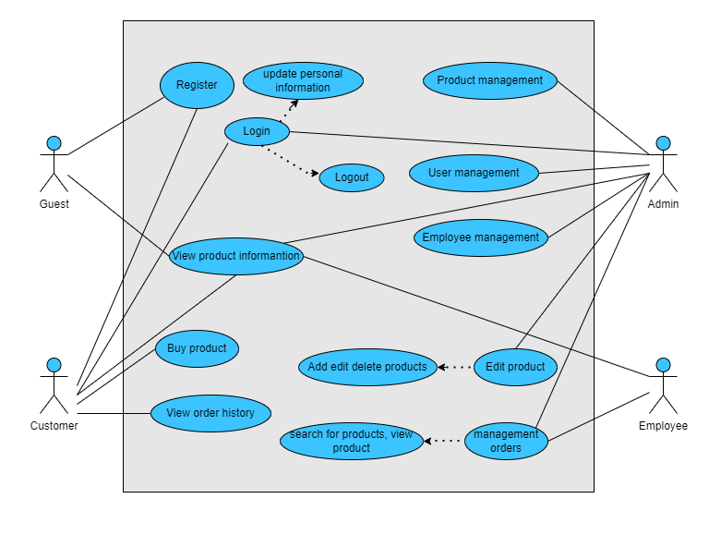

## Business process

### **The process of using the software**

* Customers visit the website to view product and service information on the website and select the products they want to buy. After logging in to their account or paying with the customer account, the customer will complete the order. and payment. Store staff pack the products and deliver them to the shipping unit. Customers receive goods and confirm order information.
* The process of using software in the project will ensure speed, accuracy and security to ensure the best buying experience for customers. Information about orders, products, customer and payment information must be strictly managed and confidential. In addition, the process of using the software also needs to be monitored to ensure correctness and avoid errors.

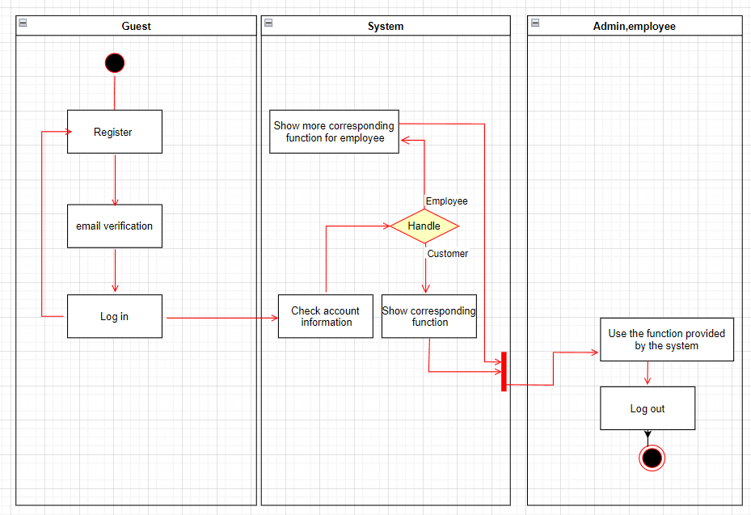

**Figure 2-4: Software usage activity chart**

### **Product management process**

Administrators and employees first need to log into the system to authenticate users. After that, the administrator has access to the quantity statistics function to check the amount of goods in the warehouse, the system will display the processing data on the screen, other functions such as adding and deleting products are similar to employees.

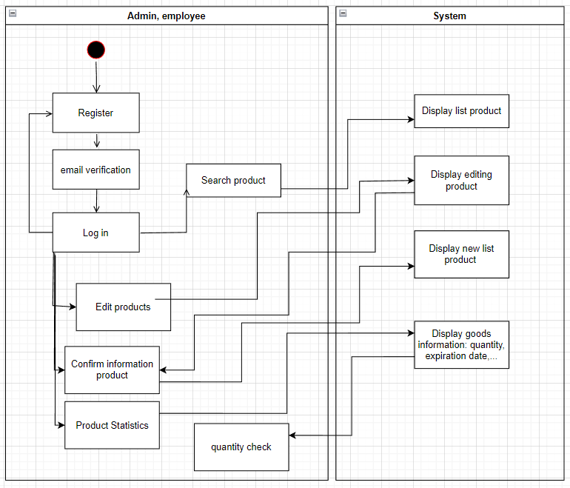

**Figure 2-6: Sales management activity chart**

### **Guest management process**

-) Guests can access the website then can use the account registration function, when they have a personal account, they will have the same functions as customers. The system will also provide a registration interface, check and save registration information.

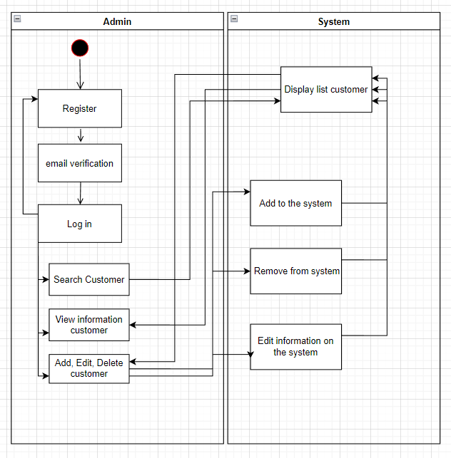

**Figure 2-7: Guest management activity chart**

### **The process of using the customer's software**

-) Customers who log in to the system can then view the list of products and the history of products that customers have previously purchased. Customers can search for products they need to refer to, buy products and give reviews for that product. The system will clearly display the information that customers need to know about the product.

-) In addition, the system gives customers the right to change their password every time they request.

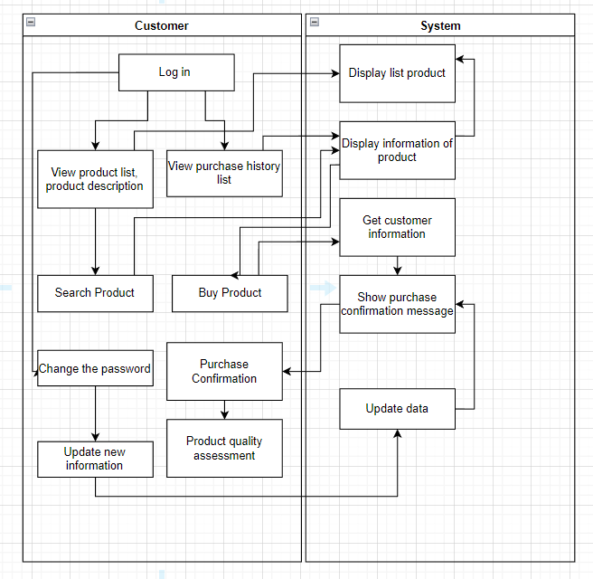

**Figure 2-9: Customer software usage process chart**

# 

# Specification of use case

## 

## 1. Login

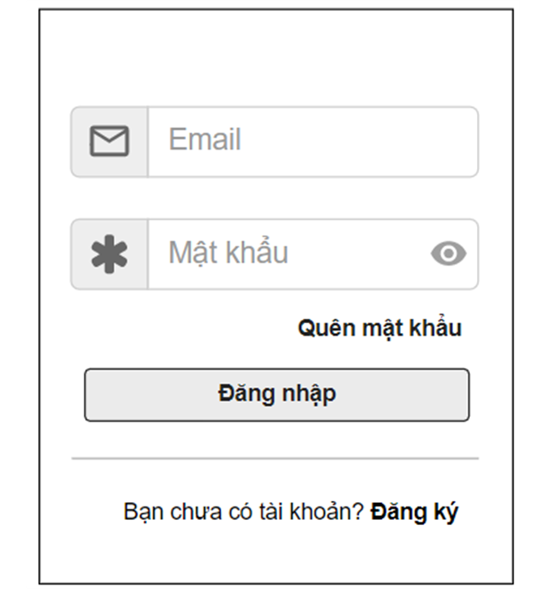

| **Use Case Name:** | Login | | |
| --- | --- | --- | --- |
| **Created By:** | Hung73 | **Last Updated By:** |  |
| **Actors:** | Admin, customers, employees | | |
| **Triggers** | Admin, customers and employees clicks on login to enter the page. | | |
| **Description:** | Admin, customers, employees login to get access to the main page. | | |
| **Pre conditions:** | Clicks button login on the web main in the tab bar. | | |
| **Post conditions:** | N/A | | |
| **Normal Flow:** | Web main | | |
| **Alternative Flows:** | N/A | | |
| **Exceptions:** | N/A | | |
| **Priority:** | Normal | | |
| **Other information:** | N/A | | |
| **Frequency of Use:** | Usually | | |
| **Business Rules:** | N/A | | |
| **Assumptions:** | N/A | | |

## 

## 2. Sign up

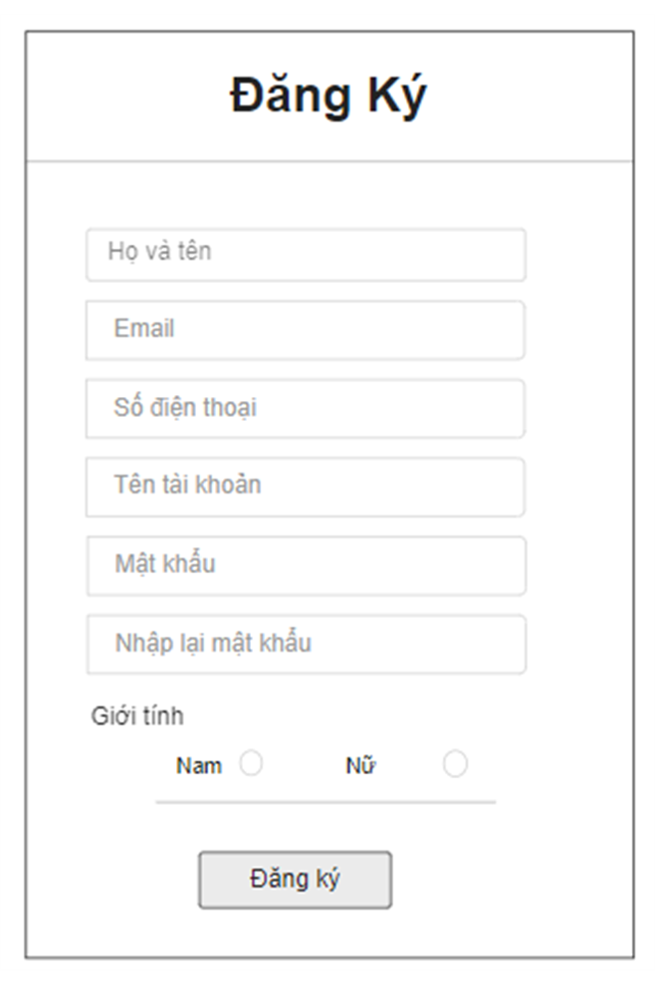

| **Use Case Name:** | Sign Up | | |
| --- | --- | --- | --- |
| **Created By:** | Hung34 | **Last Updated By:** |  |
| **Actors:** | Customers and employees | | |
| **Triggers** | Customers and employees clicks on sign up to create account | | |
| **Description:** | Customers and employees sign up to use the function of website | | |
| **Pre conditions:** | Clicks button sign up on the web main | | |
| **Post conditions:** | The new account will be save in the database | | |
| **Normal Flow:** | Web main | | |
| **Alternative Flows:** | N/A | | |
| **Exceptions:** | N/A | | |
| **Priority:** | Normal | | |
| **Other information:** | N/A | | |
| **Frequency of Use:** | Usually | | |
| **Business Rules:** | N/A | | |
| **Assumptions:** | N/A | | |

## 

## 3. View all product

| **Use Case Name:** | View all product | | |
| --- | --- | --- | --- |
| **Created By:** | Duong | **Last Updated By:** |  |
| **Actors:** | Customers, admin and employees | | |
| **Triggers** | When user clicks to product button | | |
| **Description:** | Users can see all the product that the company sell | | |
| **Pre conditions:** | When user is on the main page | | |
| **Post conditions:** | System will show the list of product for user to check the information | | |
| **Normal Flow:** | View Product List | | |
| **Alternative Flows:** | N/A | | |
| **Exceptions:** | N/A | | |
| **Priority:** | Normal | | |
| **Other information:** | N/A | | |
| **Frequency of Use:** | Usually | | |
| **Business Rules:** | N/A | | |
| **Assumptions:** | N/A | | |

## 

## 

## 4. View product by category

| **Use Case Name:** | View product by category | | |
| --- | --- | --- | --- |
| **Created By:** | Minh | **Last Updated By:** |  |
| **Actors:** | Customers, admin and employees | | |
| **Triggers** | When user clicks to category button | | |
| **Description:** | Users can see all the product by category that the company sell | | |
| **Precondition:** | When user is on the main page | | |
| **Post condition:** | System will show the list of product for user to check the information | | |
| **Normal Flow:** | View Product List by category | | |
| **Alternative Flows:** | N/A | | |
| **Exceptions:** | N/A | | |
| **Priority:** | Normal | | |
| **Other information:** | N/A | | |
| **Frequency of Use:** | Sometime | | |
| **Business Rules:** | N/A | | |
| **Assumptions:** | N/A | | |

**5. Sort product by Price**

| **Use Case Name:** | **Sort product by Price** | | |
| --- | --- | --- | --- |
| **Created By:** | Vu | **Last Updated By:** |  |
| **Actors:** | Customers, admin and employees | | |
| **Triggers** | When user clicks choose a price button | | |
| **Description:** | Users can see all the product by price that the company sell | | |
| **Pre conditions:** | When user is on the main page | | |
| **Post conditions:** | System will show the list of product for user to check the information | | |
| **Normal Flow:** | View Product List by price | | |
| **Alternative Flows:** | N/A | | |
| **Exceptions:** | N/A | | |
| **Priority:** | Normal | | |
| **Other information:** | N/A | | |
| **Frequency of Use:** | Rarely | | |
| **Business Rules:** | N/A | | |
| **Assumptions:** | N/A | | |

**6. View product_Admin**

| **Use Case Name:** | View product_Admin | | |
| --- | --- | --- | --- |
| **Created By:** | Hung73 | **Last Updated By:** |  |
| **Actors:** | Admin | | |
| **Triggers** | When user clicks to product button | | |
| **Description:** | Users can see all the product that the company sell | | |
| **Pre conditions:** | When user is on the main page | | |
| **Post conditions:** | System will show the list of product for user to check the information | | |
| **Normal Flow:** | View Product List | | |
| **Alternative Flows:** | N/A | | |
| **Exceptions:** | N/A | | |
| **Priority:** | Normal | | |
| **Other information:** | N/A | | |
| **Frequency of Use:** | Usually | | |
| **Business Rules:** | N/A | | |
| **Assumptions:** | N/A | | |

## 7. Update product_Admin

| **Use Case Name:** | Update product | | |
| --- | --- | --- | --- |
| **Created By:** | Hung73 | **Last Updated By:** |  |
| **Actors:** | Admin | | |
| **Triggers** | When admin clicks to button update product in the admin screen | | |
| **Description:** | Admin can change the information of product when the old information is incorrect | | |
| **Pre conditions:** | Use an admin account and clicks button update product on list product screen | | |
| **Post conditions:** | The change of the information will be save on the database | | |
| **Normal Flow:** | View List Product then user can clicks to product and edit the information of that product | | |
| **Alternative Flows:** | N/A | | |
| **Exceptions:** | N/A | | |
| **Priority:** | Normal | | |
| **Other information:** | N/A | | |
| **Frequency of Use:** | Sometime | | |
| **Business Rules:** | N/A | | |
| **Assumptions:** | N/A | | |

## 8.Create product_Admin

| **Use Case Name:** | Create product | | |
| --- | --- | --- | --- |
| **Created By:** | Hung73 | **Last Updated By:** |  |
| **Actors:** | Admin | | |
| **Triggers** | When admin clicks to button add product in the admin screen | | |
| **Description:** | Admin will add new product bt fill the blank of information | | |
| **Pre conditions:** | Login success to system by admin account and clicks button add new product | | |
| **Post conditions:** | The new product with the information will be add to the system | | |
| **Normal Flow:** | View List Product and user can clicks to button add and file the information of the new product. | | |
| **Alternative Flows:** | N/A | | |
| **Exceptions:** | N/A | | |
| **Priority:** | Normal | | |
| **Other information:** | N/A | | |
| **Frequency of Use:** | Sometime | | |
| **Business Rules:** | N/A | | |
| **Assumptions:** | N/A | | |

## 

## 9. Delete product_Admin

| **Use Case Name:** | Delete product | | |
| --- | --- | --- | --- |
| **Created By:** | Hung73 | **Last Updated By:** |  |
| **Actors:** | Admin | | |
| **Triggers** | When users clicks to delete button | | |
| **Description:** | Admin can delete product when the company do not sell it anymore | | |
| **Pre conditions:** | Use admin account and clicks delete button on list product screen | | |
| **Post conditions:** | The products and its information will be delete from website | | |
| **Normal Flow:** | View List Product then administrator can clicks button delete to delete that product | | |
| **Alternative Flows:** | N/A | | |
| **Exceptions:** | N/A | | |
| **Priority:** | Normal | | |
| **Other information:** | N/A | | |
| **Frequency of Use:** | Usually | | |
| **Business Rules:** | N/A | | |
| **Assumptions:** | N/A | | |

## 10. Create category

| **Use Case Name:** | Create category | | |
| --- | --- | --- | --- |
| **Created By:** | Vu | **Last Updated By:** |  |
| **Actors:** | Customers, admin, employee | | |
| **Triggers** | * When customers clicks to the order detail button * Admin and employees clicks to the orders from the list of orders | | |
| **Description:** | Users can see all the information of the order | | |
| **Pre conditions:** | Users have to login success to the main page and clicks button order detail | | |
| **Post conditions:** | The screen will show the information of order | | |
| **Normal Flow:** | View information of Order such as name of the customers order that product, number of the product, address of the customers and the money they have to pay. | | |
| **Alternative Flows:** | N/A | | |
| **Exceptions:** | N/A | | |
| **Priority:** | Normal | | |
| **Other information:** | N/A | | |
| **Frequency of Use:** | Usually | | |
| **Business Rules:** | N/A | | |
| **Assumptions:** | N/A | | |

## 

## 11. Delete category

| **Use Case Name:** | Delete category | | |
| --- | --- | --- | --- |
| **Created By:** | Vu | **Last Updated By:** |  |
| **Actors:** | Admin | | |
| **Triggers** | When users clicks to delete button | | |
| **Description:** | Admin can delete category when the company do not sell it anymore | | |
| **Pre conditions:** | Use admin account and clicks delete button on list category screen | | |
| **Post conditions:** | The category and its information will be delete from website | | |
| **Normal Flow:** | View List Category then administrator can clicks button delete to delete that category. | | |
| **Alternative Flows:** | N/A | | |
| **Exceptions:** | N/A | | |
| **Priority:** | Normal | | |
| **Other information:** | N/A | | |
| **Frequency of Use:** | Usually | | |
| **Business Rules:** | N/A | | |
| **Assumptions:** | N/A | | |

## 12. Update category

| **Use Case Name:** | Update category | | |
| --- | --- | --- | --- |
| **Created By:** | Vu | **Last Updated By:** |  |
| **Actors:** | Admin | | |
| **Triggers** | When admin cicks to button edit category in the admin screen | | |
| **Description:** | Admin can change the information of category when the old information is incorrect | | |
| **Pre conditions:** | Use an admin account and clicks button edit category on list category screen | | |
| **Post conditions:** | The change of the information will be save on the database | | |
| **Normal Flow:** | View List Category then user can clicks to category and edit the information of that category | | |
| **Alternative Flows:** | N/A | | |
| **Exceptions:** | N/A | | |
| **Priority:** | Normal | | |
| **Other information:** | N/A | | |
| **Frequency of Use:** | Usually | | |
| **Business Rules:** | N/A | | |
| **Assumptions:** | N/A | | |

## 

## 13. View category_Admin

| **Use Case Name:** | View category | | |
| --- | --- | --- | --- |
| **Created By:** | Vu | **Last Updated By:** |  |
| **Actors:** | Admin | | |
| **Triggers** | Admin clicks button list category | | |
| **Description:** | Admin can see the information list category | | |
| **Pre conditions:** | Admin login success to the website by admin account | | |
| **Post conditions:** | System will view the list category | | |
| **Normal Flow:** | View List category: name and the id of category | | |
| **Alternative Flows:** | N/A | | |
| **Exceptions:** | N/A | | |
| **Priority:** | Normal | | |
| **Other information:** | N/A | | |
| **Frequency of Use:** | Usually | | |
| **Business Rules:** | N/A | | |
| **Assumptions:** | N/A | | |

# IV. Non-functional Requirement

## 1. User Interface

**-** The interface looks good on different devices.

- Customers when accessing and using the system, the system will receive request and return to the browser functions menu corresponding to each user’s scope.

## 2. Security

- Users can only use functions and access data that are appropriate for the role of that users.

- When sign up customers need to create an account with their email and they need to agree with website’s privacy.

## 3. Constraint

- Users need connected devices with the internet such as computer and provided services such as email to be able to send and receive information.

# 

# V. Other Requirement

## Appendix A: Database diagram

**//To add**

**Appendix B: Diagram Entity**

## 1. Product

## 2. Order Details

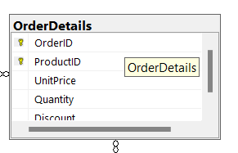

Include fields: [OrderID], [ProductID], [UnitPrice], [Quantity], [Discount]

## 

## 3. Orders

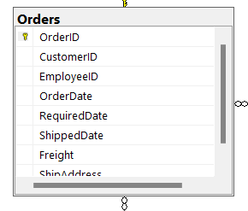

Include fields: [OrderID], [CustomerID], [EmployeeID], [OrderDate], [Requireddate], [ShippedDate], [Freight], [ShipAddress]

## 

## 4. Employees

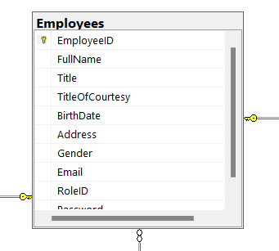

Include fields: [EmployeeID], [FullName], [Title], [TitleOfCourtesy], [BirthDate], [Address], [Gender], [Email], [RoleID], [Password]

## 5. Roles

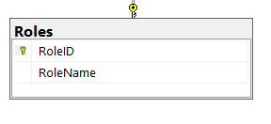

Include fields: [RoleID], [RoleName]